Business Case

*for the*

Unmanned

Control & Tracking System

**(UCATS)**

**DJ³K Team**

Kurt Chewning

Jennifer Greene

Dave Manley

Jeanette Smith

John Smith

Sponsors: Dr. Kuo-Chu Chang

&

Ashwin Samant



Department of Systems Engineering & Operations Research

SYST 798 Applied Projects Course

Fall 2009

**TABLE OF CONTENTS**

1.0 Introduction 3

2.0 Financial Model 3

2.1 Cost 4

2.2 Price 4

2.3 Cash Flow Analysis and Net Present Value 5

2.4 Internal Rate of Return 5

2.5 Breakeven Point 5

2.6 Expected Value of Probability Distribution 5

3.0 Sensitivity Analyses 7

3.1 Cash Flow charts 7

3.2 Tornado Diagrams 8

3.3 Risk Profile 10

4.0 Production 11

5.0 Market Introduction Strategy 11

5.1 Stakeholder Insight 13

5.2 Business Concept Requirements 14

6.0 Conclusion 14

APPENDICES 15

Appendix A: Acronyms 16

Appendix B: UCATS Baseline Business Case Input 16

Appendix C: Better Option than Baseline UCATS Business Case Inputs 19

Appendix D: Worse Option than Baseline UCATS Business Case Inputs 22

Appendix E: Expert COSYSMO Calculator 25

# 1.0 Introduction

The Unmanned Control & Tracking System (UCATS) is intended to autonomously track targets of interest in an urban environment using multiple unmanned aerial vehicles (UAVs). The UCATS product includes a ground control station, communication and encryption equipment, a graphical user interface, and newly designed and implemented algorithm. This algorithm is unique in the sense that it prioritizes targets and optimally assigns UAVs to targets of interest. The end result is a reduction in the manpower needed to control up to 5 UAVs.

This Business Case provides a description of the economic factors that were used to develop cost estimates. This document takes into consideration the inputs from the Stakeholder Value Mapping (SVM) Document. Team DJ³K’s business concept for UCATS is to develop it using sponsor funding and sell it to DoD customers. Once UCATS is developed, Team DJ³K intends to seek out additional customers in military, homeland defense, and law enforcement that may be interested in procuring UCATS.

# 2.0 Financial Model

Before creating a cost model, Team DJ³K performed a decision analysis using an influence diagram and decision tree. These were used to determine whether it was more favorable to develop the system in-house or hire a sub-contractor. The analysis determined that the best option was to develop the system in-house. Section 2.6 contains more detail regarding these analyses.

A Cost Model was created in Excel using Dr. Speller’s Case study as an example to estimate the cost per unit, cost per year, return on investment, the net cash of the program, revenues, investment, and the production and delivery of units over a period of 10 years. A total number of 91 units would be produced and delivered in this period of time. In addition, a sensitivity analysis was performed on the baseline, which included a better option (more favorable market conditions) and a worse option (less favorable market conditions). This sensitivity analysis was performed to determine how market fluctuations can affect the profitability and risk of the project.

Also, the Team contacted General Atomics, which is a leading designer and manufacturer of UAV systems, in order to obtain realistic price estimates for existing ground control stations. See the excel spreadsheet for more details on the business case model.

See appendix B for charts, tables and graphs on the baseline case and see the UCATS Business Case file in excel for more cost details. The following sections refer to the baseline values (Excel spreadsheet UCATS_Business_Case.xls) for the financial model.

## 2.1 Cost

The UCATS cost per unit is $721,900. This cost was calculated using the Overhead cost, Hardware cost, Software Development cost, and the Google Earth License cost. The Overhead cost was assumed to be $100,000 per unit. This cost includes the operation and maintenance costs (personnel, facilities, utilities, energy). The Hardware cost includes the cost of an Encryption Module ($2,000), UAV antenna ($400,000), cost of a ground communications shelter ($200,000), radio for the UAV without encryption gear capability ($1,000), cost of video and UCATS displays ($300 each), spare equipment ($4,300) and a Processor ($4,000). The Hardware cost is the result of the UCATS Communications Physical Architecture Study performed by the Team DJ³K. The Google Earth License Fee is $10,000 for the first year and it is assumed that the customer has to continue paying the license fee after the first year.

The investment cost was estimated for a period of 6 years. This cost is composed of the Software Development Cost, the System Development Detailed Production, Planning and Design cost, the Supply Support cost and the Retirement and Disposal cost. The Software Development cost was estimated at $ 12,615,986 using expert COSYSMO- System Engineering Cost Model Risk Advisor, which is a model that provides estimates for cost, effort, and schedule when planning a new software development project. The System Development Detailed Production, Planning, and Design costs were obtained from the UCATS Communications Physical Architecture Study. This study includes system development costs, detailed design, and verification testing. The Supply Support cost includes inventory and training cost. See Appendix E for the COSYSMO details.

For the purposes of this cost analysis, the cost of the UAV itself was not included. This is because the UCATS will not be designed to operate with a specific UAV, but rather will allow the customer to choose the UAV system it will control.

## 2.2 Price

DJ³K determined the price of UCATS at $1,600,000 per unit. This price was determined using several factors. First, the Team obtained an estimated price range from a leading vendor of UAV systems (General Atomics). They indicated that a ground control station, excluding the actual aircraft, was anywhere from $500,000 to $3 million. The lower end of the range represents a station with no options (air conditioning, satellite communication, encryption, single aircraft, battery backup, etc.). Adding in all the extras would take the estimate closer the higher end of the range. This is also assuming that the ground control station does not have the desired multi-UAV algorithm implemented, which would add to the cost. The vendor was reluctant to share specific pricing information.

Another factor that was used in determining the price was profitability. The Team wanted to make sure that the product would produce a positive return on investment, and be able to beat the S&P 500 historical rate of return (10%). Additionally, the Team wanted to make sure the internal rate of return was greater than or equal to 25%.

## 2.3 Cash Flow Analysis and Net Present Value

The cash flow analysis involves determining the net cash, which is calculated by subtracting the outgoing cash from the revenues. The net cash is then adjusted to account for the time value of money by multiplying by a discount factor. The percentage rate used was 10%, which was determined by comparing with the next best investment option (S&P 500). The discounted cash total, or net present value (NPV) for the baseline was $20,894,683.This means that a net positive cash flow was obtained, when adjusted for time.For more details see the Excel spreadsheet UCATS_Business_Case.xls, under the Baseline Calculation Sheet.

## 2.4 Internal Rate of Return

The internal rate of return is the interest rate that will make NPV equal to 0. In other words, it is a measure the profitability of this investment. The baseline internal rate of return (IRR) was 25%. This means that at 25% interest rate, all gains from this investment would be equal to the expenses, when taking into account the time value of money. The better option IRR was 40% and the worse option IRR was 19%.

## 2.5 Breakeven Point

The breakeven point illustrates the point in time where the expenses are equal to the revenues for a particular investment. At this point, the investment is said to become profitable. For the baseline analysis, the breakeven point is approximately 7 years.

## 2.6 Expected Value of Probability Distribution

DPL (Decision Programming Language) was used to create an influence diagram and a decision tree. The main decision being considered is whether or not developing in-house is more favorable financially than hiring a sub-contractor. This decision node affected the costs, since producing in-house costs less than buying from a contractor. However, buying from a contractor also affected the sales, since the Team assumed that sales would tend to be higher (probabilistically) if the product was manufactured by an experienced company. The expected value being analyzed is the generated profit. The influence diagram is illustrated below in Figure 1.

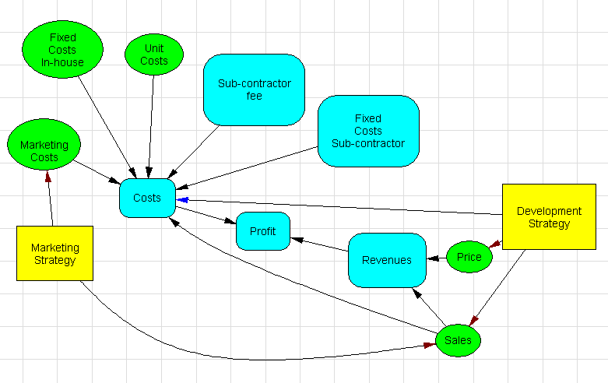

Figure 1: The Influence Diagram for the UCATS Business Case

A second decision was also included in this influence diagram, which involved a marketing strategy. The decision involves whether to use heavy advertising (higher costs, potentially higher sales) or light advertising (lower costs, potentially lower sales). The recommended decision was to use heavy advertising.

The expected values (profit) from the decision tree were obtained as indicated in Figure 2. This diagram also includes the second decision involving the marketing strategy. The expected value for the decision tree was $54,605,642.75.

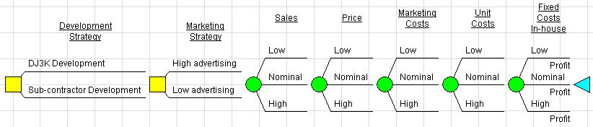

Figure 2: The UCATS Decision Tree with Expected Values

# 3.0 Sensitivity Analyses

Sensitivity analyses were performed to understand the possible risk involved in this particular investment. To perform the sensitivity analyses the team used Excel as well as DPL. The NPV, IRR and payback period were determined for three different market situations: baseline, better option, and worse option. The DPL model was used to create tornado diagrams and a risk profile chart.

## 3.1 Cash Flow charts

The cash flow analysis described in section 2.3 represents the baseline. For the first sensitivity analysis, several factors were modified to create two distinct situations, which represented an improved market (referred to as the “better option”) and another representing a worse market (the “worse option”). These combinations represent future uncertainty in market conditions. The factors that were modified were:

* Cost-of-capital – increased for worse option
* Revenue price – increased for better option
* Investment costs per year – increased for worse option, and decreased for better option

As expected, the better option resulted in improved numbers. However, it is important to note the extent of the improvement. Table 1 summarizes the results for the sensitivity analysis.

|  |  |  |  |
| --- | --- | --- | --- |
|  | **Worse** | **Baseline** | **Better** |
| **NPV** | $4,729,614 | $20,894,683 | $41,144,092 |
| **IRR** | 19% | 25% | 40% |
| **Breakeven point** | 8.6 yrs | 7 yrs | 5.2 yrs |
| **Cost-of-Capital** | 15% | 10% | 10% |

Table 1: Results Summary for Cash Flow Sensitivity Analysis

The cash flow charts for each of the cases is included in the Appendix B, C and D.

## 3.2 Tornado Diagrams

The second sensitivity analysis was performed using tornado diagrams to determine which variables have the most influence. A Value Tornado Diagram was created to evaluate the model with the selected values at specified low and high bounds. Figure 3 illustrates that none of the fixed values had any significant effect on the profit.

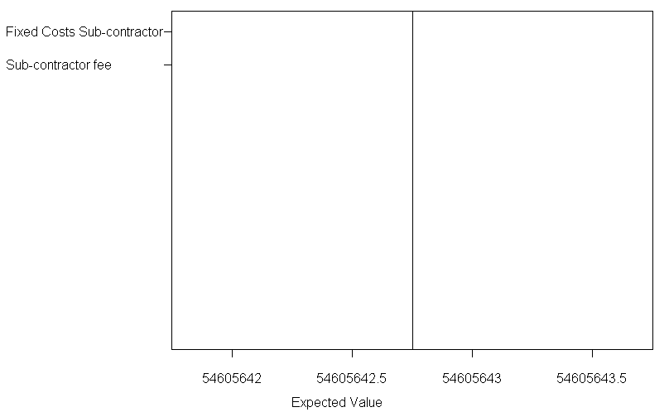

Figure 3: Value Case Tornado Diagram

A Base Tornado Diagram was created varying each chance event through low, nominal and high states. Figure 4 illustrates that the Price had the most impact on the expected profit. The variable of Sales also varied the expected value. The low setting policy change had a greater expected value. As seen in the figure, Marketing Costs had the least effect on the expected profit value.

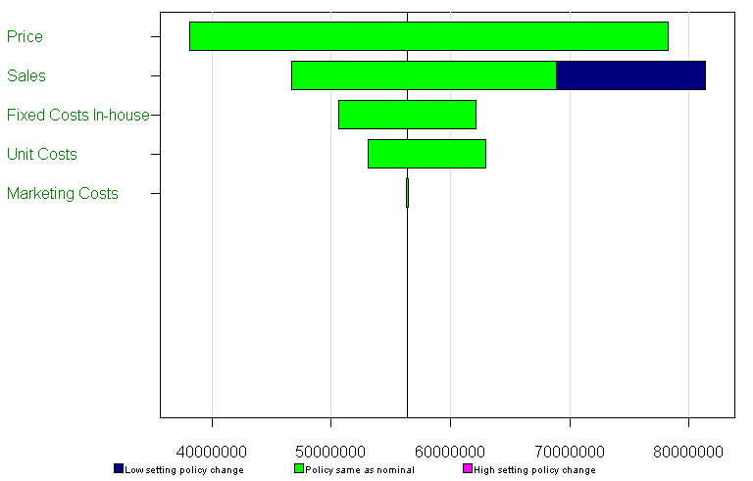

Figure 4: Base Tornado Diagram

An Initial Decision Alternative tornado diagram was performed as well. There are only two initial decision alternatives (in-house vs. subcontractor) so the tornado diagram consists of two Base Case tornados which are demonstrated in the figure below. The diagram shows that the chance event of Price has the biggest impact on the objective value function regardless of which initial alternative is pursued. The chance event of Sales has the biggest impact if the product is developed by Team DJ³K.

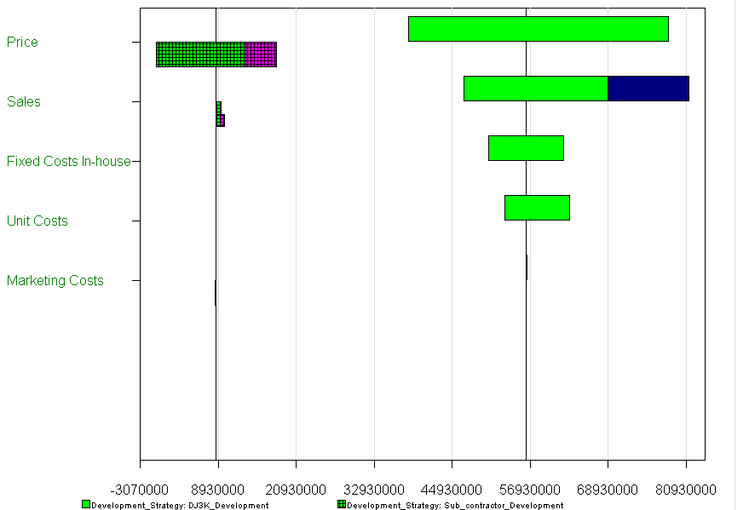

Figure 5: Initial Decision Alternative Tornado diagram

## 3.3 Risk Profile

A cumulative Risk Profile graph was created in DPL to display the objective function on the vertical axis and a cumulative probability on the horizontal axis. This graph shows that, for the expected value, the cumulative probability is less than or equal to 50. Therefore, in 50% of the scenarios the objective function is equal to or less than the expected value.

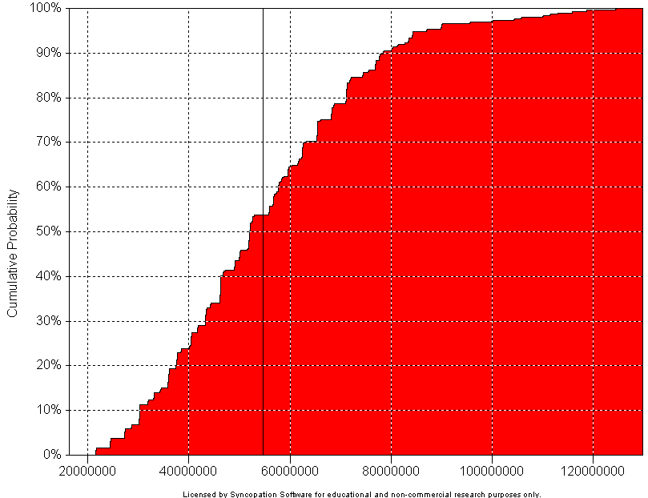

Figure 6: Risk Profile Graph

The Statistics dialog shown in Figure 7 includes the statistical description of the distribution of objective function, including the minimum and maximum values, the variance and standard deviation, the higher moments, and the percentiles of the distribution. The percentiles table shows that the 10th percentile of the distribution is $30,202,585. It also shows that 90% of the time, the objective function will be less than or equal to $78,509,621.

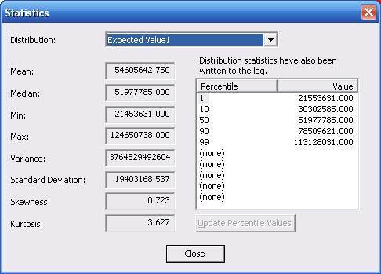

Figure 7: Risk Profile Statistics

# 4.0 Production

A complete prototype unit will be manufactured and assembled during the first two years. The total unit production goal is 91 units in 10 years time. In order to meet this goal, it will be important to design for manufacturability in order to simplify assembly operations.

Supply chain specialists should be included in the UCATS production plans to aid in the purchasing, production and distribution of the suppliers and customers of the system. It is extremely important that customer demands are satisfied with the product and that the use of resources be maximized. Another important goal is to match the supply with the demand with minimal inventory. It is assumed that the UCATS units produced will all be sold for this project but this will not be the case in real life. It is very important that a good relationship with suppliers be maintained.

# 5.0 Market Introduction Strategy

The marketing strategy will mainly focus on the need to reduce manpower. In all parts of the government and branches of the military, one of the main goals is the reduction in the number of people required to carry out their missions. Defense Secretary Robert M. Gates recently announced that he would halt the Air Force’s plan to cut the size of its force from 360,000 to 316,000 personnel[1]. Lean manning has already been occurring in the Navy since the early 2000’s[2]. In general, all branches of the government have been trying to perform more work with fewer resources. Additionally, the field of air-vehicle autonomy is a recently emerging field, whose economics is largely driven by the military to develop battle-ready technology. Compared to the manufacturing of UAV flight hardware, the market for autonomy technology is fairly immature and undeveloped. Because of this, autonomy has been and may continue to be the bottleneck for future UAV developments, and the overall value and rate of expansion of the future UAV market could be largely driven by advances to be made in the field of autonomy. By emphasizing the need for reducing the number of operators required, coupled by the already evident benefit of flying an unmanned aircraft (i.e. reduction in collateral damage, etc.) the UCATS product will fill a critical void in today’s market.

With a market value of $2.2 billion in 2007 (Figure 8 below), UAVs represent the largest and most mature segment in the unmanned systems marketplace[3].

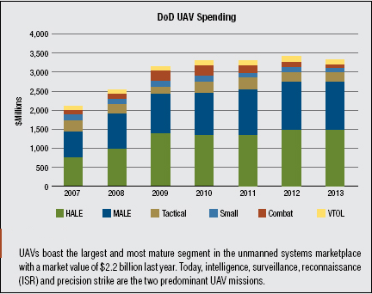

Figure 8: DoD UAV Spending

As the result of successful performances in Iraq and Afghanistan, UAVs that fly high and medium altitude long endurance missions have been the beneficiaries of the latest technologies and consequently received more than $1.8 billion in DoD funding in 2007. Eighty percent of this spending went to the U.S. Air Force’s medium altitude long endurance (MALE) and high altitude long endurance (HALE) platforms. However, the USAF is not the only military service with these capabilities; the Navy’s Broad Area Maritime Surveillance (BAMS) program will have a substantial impact on defense spending in addition to the Army’s Extended Range, Multi Purpose (ERMP) aircraft. These two programs are expanding long endurance UAV capabilities across the military services.

## 5.1 Stakeholder Insight

Dr. KC Chang is the project sponsor. He obtained a Small Business Technology Transfer (STTR) project from the Air Force Office of Scientific Research (AFSOR) to develop the tracking and control algorithms. Therefore, the UCATS primary customers are military. Specifically the Air Force; however, other Government entities, such as Homeland Defense and Law Enforcement organization are another viable customer for UCATS. Finally, while the urban communities are not UCATS customers, they do have a significant impact on the UCATS business concept. Each of these organizations has slightly different impacts on the UCATS business concept. In summary:

* **Military Customers:** Military customers are more concerned about life cycle cost than unit costs. Typically, if a system provides a needed service, the military is not overly restricted by the unit cost of a system. However, the military customers do pay attention to life cycle costs. Since UCATS is PC based, the life cycle costs for hardware should be minimal, but key life cycle cost drivers for the military include:
  1. *Training:* The UCATS needs to be fairly simple to learn. If the UCATS requires significant training, then costs will rise due to excessive training cycle times, training material costs, and any training facility costs.
  2. *Maintenance:* The primary maintenance costs incurred by UCATS will be software maintenance costs. Since UCATS is PC based, hardware costs should be minimal. Therefore, the UCATS should be architected to minimize the costs incurred during software modification and the UCATS should use open architecture principles to minimize the costs associated with interface modifications, which will undoubtedly occur. Additionally, depending on the instantiated communications design, the UCATS may incur some maintenance costs to maintain the communication functionality.
* **Homeland Defense and Law Enforcement Customers:** The Homeland Defense and Law Enforcement customers will likely be more focused on unit cost than the military customers, and they will be as interested in minimizing life cycle costs as the military customers. Since UCATS is PC based and the military is currently sponsoring the development of the UCATS software, the unit cost to Homeland Defense and Law Enforcement customers should be minimal. However, the communications solution may be costly; therefore, the UCATS should strive to minimize the communications sub-system costs.
* **Industry Customers:** The UCATS is not marketed towards industry customers. However, should they be interested, the cost drivers for the Homeland Defense and Law Enforcement customers should be the same as the industry customers.
* **Urban Communities:** Urban communities will not buy UCATS; however, they potentially have the greatest economic impact on UCATS. The UCATS must provide safe and reliable intercept plans to the UAVs. The liability incurred by a UAV hitting a building because the UCATS provided an incorrect intercept path could be substantial.

## 5.2 Business Concept Requirements

Based on the above assessment of the potential customers’ economic interests, the business related UCATS requirements are:

* The UCATS should minimize unit cost, especially the communication system costs.
* The UCATS should minimize training requirements.
* The UCATS software should use open architecture principles.
* The UCATS should minimize maintenance costs, especially the costs needed to modify and update the UCATS software.
* The UCATS shall provide safe and reliable intercept recommendations to the operator.

# 6.0 Conclusion

This document contains the results of the business case: price, cash flow analysis, net present value, internal rate of return, and breakeven point. A sensitivity analysis was performed on the baseline, which included a better option (more favorable market conditions) and a worse option (less favorable market conditions). This sensitivity analysis was performed to determine how market fluctuations can affect the profitability and risk of the project. Team DJ³K also performed a decision analysis using an influence diagram and decision tree. These were used to determine whether it was more favorable to develop the system in-house or hire a sub-contractor. The analysis determined that the best option was to develop the system in-house.

# APPENDICES

# Appendix A: Acronyms

DPL Decision Programming Language

IRR Internal Rate of Return

UAVs Unmanned Aerial Vehicles

UCATS Unmanned Control & Tracking System

# Appendix B: UCATS Baseline Business Case Input

|  |  |  |  |  |  |  |  |  |
| --- | --- | --- | --- | --- | --- | --- | --- | --- |
| **Baseline Business Case Inputs** | | | | | | | | |
|  |  |  |  |  |  |  |  |  |
|  |  |  |  |  |  |  |  |  |
|  |  | **Revenues** |  |  | **Schedules** |  |  |  |
|  |  | **Price** | **Price Concessions %** |  |  | **Production** | **Delivery** |  |
|  |  | $1,600,000 | 0% |  | Yr1 | 0 | 0 |  |
|  |  |  |  |  | Yr2 | 1 | 1 |  |
|  | **Investment Costs** | | **Recurring Costs** |  | Yr3 | 2 | 2 |  |
|  | **Year** | **Cost Per Year** | **Cost Per Unit** |  | Yr4 | 4 | 4 |  |
|  | 1 | $14,403,385 | $721,900 |  | Yr5 | 6 | 6 |  |
|  | 2 | $2,880,677 |  |  | Yr6 | 8 | 8 |  |
|  | 3 | $1,440,338 |  |  | Yr7 | 10 | 10 |  |
|  | 4 | $1,440,338 |  |  | Yr8 | 15 | 15 |  |
|  | 5 | $1,440,338 |  |  | Yr9 | 20 | 20 |  |
|  | 6 | $1,440,338 |  |  | Yr10 | 25 | 25 |  |
|  |  |  |  |  |  | 91 |  |  |
|  |  | **Project Totals** |  |  |  |  |  |  |
|  |  | Investment | $23,045,415 |  |  |  |  |  |
|  |  | Revenues | $145,600,000 |  |  |  |  |  |
|  |  | Recurring Costs | $65,692,900 |  |  |  |  |  |
|  |  | **Net Cash Program** | **$56,861,685** |  |  |  |  |  |
|  |  | **Return on Investment** |  |  |  |  |  |  |
|  |  | **NPV To Shareholders** | **$20,894,683** |  |  |  |  |  |
|  |  | **Internal Rate of Return** | **25%** |  |  |  |  |  |
|  |  |  |  |  |  |  |  |  |
|  |  |  |  |  |  |  |  |  |
|  |  | **Cost-of-Capital** | **10%** |  |  |  |  |  |
|  |  | **Cost of Software Development** | **$12,615,986** |  |  |  |  |  |
|  |  | **System Development Detailed Production, Planning and Design Cost** | **$410,000** |  |  |  |  |  |
|  |  | **Supply Support Cost** | **$43,000** |  |  |  |  |  |
|  |  | **Retirement and Disposal Cost** | **$25,000** |  |  |  |  |  |
|  |  |  |  |  |  |  |  |  |

|  |  |  |  |  |  |  |  |
| --- | --- | --- | --- | --- | --- | --- | --- |
| **Timing of Cash Receipt or Expenditure** | **Year** |  | **Cash-In (Income)** | **Cash-Out (Expense)** | **Net Cash** | **Discount Factor** | **Discounted Cash** |
| Year 1 | 0 |  | $0 | $14,403,385 | ($14,403,385) | 1.000 | ($14,403,385) |
| Year 2 | 1 |  | $1,600,000 | $3,602,577 | ($2,002,577) | 0.909 | ($1,820,524) |
| Year 3 | 2 |  | $3,200,000 | $2,884,138 | $315,862 | 0.826 | $261,043 |
| Year 4 | 3 |  | $6,400,000 | $4,327,938 | $2,072,062 | 0.751 | $1,556,771 |
| Year 5 | 4 |  | $9,600,000 | $5,771,738 | $3,828,262 | 0.683 | $2,614,754 |
| Year 6 | 5 |  | $12,800,000 | $7,215,538 | $5,584,462 | 0.621 | $3,467,511 |
| Year 7 | 6 |  | $16,000,000 | $7,219,000 | $8,781,000 | 0.564 | $4,956,646 |
| Year 8 | 7 |  | $24,000,000 | $10,828,500 | $13,171,500 | 0.513 | $6,759,062 |
| Year 9 | 8 |  | $32,000,000 | $14,438,000 | $17,562,000 | 0.467 | $8,192,803 |
| Year 10 | 9 |  | $40,000,000 | $18,047,500 | $21,952,500 | 0.424 | $9,310,003 |
|  | Totals | **Totals** | **$145,600,000** | **$88,738,315** | **$56,861,685** |  | **$20,894,683** |
|  |  |  |  |  |  |  |  |
|  |  |  |  |  |  |  |  |
|  |  |  |  |  | Net Present Value (NPV) | | $20,894,683 |
|  |  |  |  |  | Discounting Rate | | 10% |
|  |  |  |  |  | Internal Rate of Return (IRR) | | 25% |

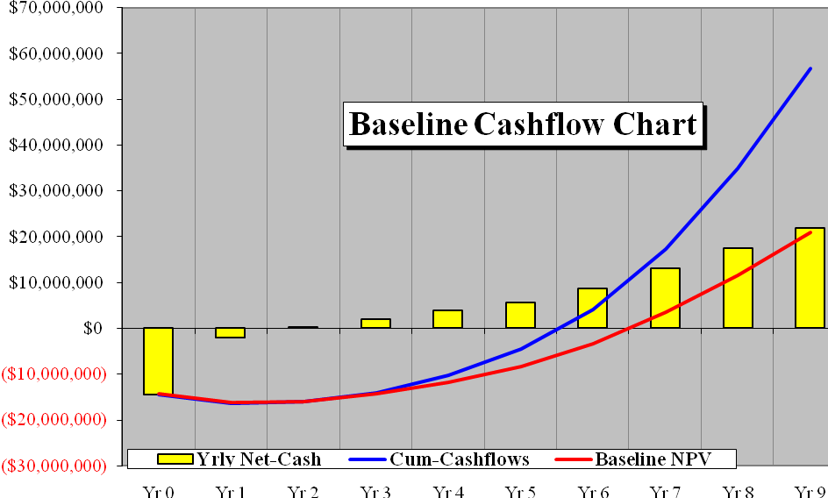

# Appendix C: Better Option than Baseline UCATS Business Case Inputs

|  |  |  |  |  |  |  |  |  |
| --- | --- | --- | --- | --- | --- | --- | --- | --- |
| **Better Option than Baseline Business Case Study Inputs** | | | | | | | | |
|  |  |  |  |  |  |  |  |  |
|  |  |  |  |  |  |  |  |  |
|  |  | **Revenues** |  |  | **Schedules** |  |  |  |
|  |  | **Price** | **Price Concessions %** |  |  | **Production** | **Delivery** |  |
|  |  | $1,840,000 | 0% |  | Yr1 | 0 | 0 |  |
|  |  |  |  |  | Yr2 | 1 | 1 |  |
|  | **Investment Costs** |  | **Recurring Costs** |  | Yr3 | 2 | 2 |  |
|  | **Year** | **Cost Per Year** | **Cost Per Unit** |  | Yr4 | 4 | 4 |  |
|  | 1 | $10,802,538 | $649,710 |  | Yr5 | 6 | 6 |  |
|  | 2 | $2,160,508 |  |  | Yr6 | 8 | 8 |  |
|  | 3 | $1,080,254 |  |  | Yr7 | 10 | 10 |  |
|  | 4 | $1,080,254 |  |  | Yr8 | 15 | 15 |  |
|  | 5 | $1,080,254 |  |  | Yr9 | 20 | 20 |  |
|  | 6 | $1,080,254 |  |  | Yr10 | 25 | 25 |  |
|  |  |  |  |  |  | 91 |  |  |
|  |  | **Project Totals** |  |  |  |  |  |  |
|  |  | Investment | $17,284,062 |  |  |  |  |  |
|  |  | Revenues | $167,440,000 |  |  |  |  |  |
|  |  | Recurring Costs | $59,123,610 |  |  |  |  |  |
|  |  | **Net Cash Program** | **$91,032,328** |  |  |  |  |  |
|  |  | **Return on Investment** |  |  |  |  |  |  |
|  |  | **NPV To Shareholders** | **$41,144,092** |  |  |  |  |  |
|  |  | **Internal Rate of Return** | **40%** |  |  |  |  |  |
|  |  |  |  |  |  |  |  |  |
|  |  |  |  |  |  |  |  |  |
|  |  | **Cost-of-Capital** | **10%** |  |  |  |  |  |
|  |  | **Cost of Software Development** | **$12,615,986** |  |  |  |  |  |
|  |  | **System Development Detailed Planning and Design Cost** | **$410,000** |  |  |  |  |  |
|  |  | **Supply Support Cost** | **$43,000** |  |  |  |  |  |
|  |  | **Retirement and Disposal Cost** | **$25,000** |  |  |  |  |  |
|  |  |  |  |  |  |  |  |  |

|  |  |  |  |  |  |  |
| --- | --- | --- | --- | --- | --- | --- |
| **Timing of Cash Receipt or Expenditure** |  | **Cash-In** | **Cash-Out** | **Net Cash** | **Discount Factor** | **Discounted Cash** |
| Year 1 |  | $0 | $10,802,538 | ($10,802,538) | 1.000 | ($10,802,538) |
| Year 2 |  | $1,840,000 | $2,810,218 | ($970,218) | 0.909 | ($882,016) |
| Year 3 |  | $3,680,000 | $2,379,674 | $1,300,326 | 0.826 | $1,074,650 |
| Year 4 |  | $7,360,000 | $3,679,094 | $3,680,906 | 0.751 | $2,765,519 |
| Year 5 |  | $11,040,000 | $4,978,514 | $6,061,486 | 0.683 | $4,140,077 |
| Year 6 |  | $14,720,000 | $6,277,934 | $8,442,066 | 0.621 | $5,241,859 |
| Year 7 |  | $18,400,000 | $6,497,100 | $11,902,900 | 0.564 | $6,718,877 |
| Year 8 |  | $27,600,000 | $9,745,650 | $17,854,350 | 0.513 | $9,162,105 |
| Year 9 |  | $36,800,000 | $12,994,200 | $23,805,800 | 0.467 | $11,105,581 |
| Year 10 |  | $46,000,000 | $16,242,750 | $29,757,250 | 0.424 | $12,619,979 |
|  | **Totals** | **$167,440,000** | **$76,407,672** | **$91,032,328** |  | **$41,144,092** |
|  |  |  |  |  |  |  |
|  |  |  |  | Net Present Value (NPV) | | $41,144,092 |
|  |  |  |  | Discounting Rate | | 10% |
|  |  |  |  | Internal Rate of Return (IRR) | | 40% |

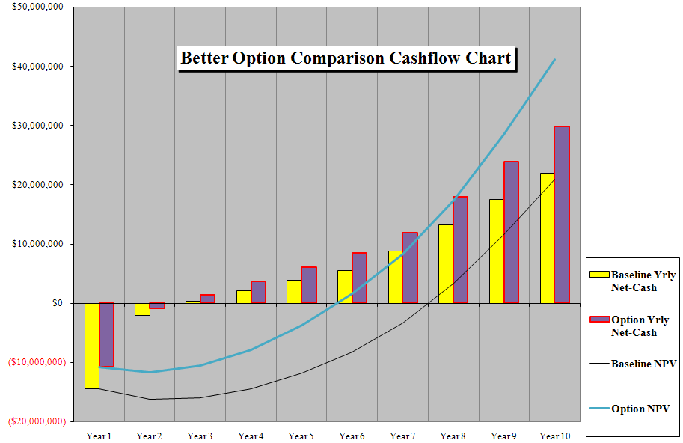

# 

# Appendix D: Worse Option than Baseline UCATS Business Case Inputs

|  |  |  |  |  |  |  |  |  |
| --- | --- | --- | --- | --- | --- | --- | --- | --- |
| **Worse Option than Baseline Business Case Study Inputs** | | | | | | | | |
|  |  |  |  |  |  |  |  |  |
|  |  |  |  |  |  |  |  |  |
|  |  | **Revenues** |  |  | **Schedules** |  |  |  |
|  |  | **Price** | **Price Concessions %** |  |  | **Production** | **Delivery** |  |
|  |  | $1,600,000 | 0% |  | Yr1 | 0 | 0 |  |
|  |  |  |  |  | Yr2 | 1 | 1 |  |
|  | **Investment Costs** |  | **Recurring Costs** |  | Yr3 | 2 | 2 |  |
|  | **Year** | **Cost Per Year** | **Cost Per Unit** |  | Yr4 | 4 | 4 |  |
|  | 1 | $18,004,231 | $757,995 |  | Yr5 | 6 | 6 |  |
|  | 2 | $3,600,846 |  |  | Yr6 | 8 | 8 |  |
|  | 3 | $1,800,423 |  |  | Yr7 | 10 | 10 |  |
|  | 4 | $1,800,423 |  |  | Yr8 | 15 | 15 |  |
|  | 5 | $1,800,423 |  |  | Yr9 | 20 | 20 |  |
|  | 6 | $1,800,423 |  |  | Yr10 | 25 | 25 |  |
|  |  |  |  |  |  | 91 |  |  |
|  |  | **Project Totals** |  |  |  |  |  |  |
|  |  | Investment | $28,806,769 |  |  |  |  |  |
|  |  | Revenues | $145,600,000 |  |  |  |  |  |
|  |  | Recurring Costs | $68,977,545 |  |  |  |  |  |
|  |  | **Net Cash Program** | **$47,815,686** |  |  |  |  |  |
|  |  | **Return on Investment** |  |  |  |  |  |  |
|  |  | **NPV To Shareholders** | **$4,729,614** |  |  |  |  |  |
|  |  | **Internal Rate of Return** | **19%** |  |  |  |  |  |
|  |  |  |  |  |  |  |  |  |
|  |  |  |  |  |  |  |  |  |
|  |  | **Cost-of-Capital** | **15%** |  |  |  |  |  |
|  |  | **Cost of Software Development** | **$12,615,986** |  |  |  |  |  |
|  |  | **System Development Detailed Planning and Design Cost** | **$410,000** |  |  |  |  |  |
|  |  | **Supply Support Cost** | **$43,000** |  |  |  |  |  |
|  |  | **Retirement and Disposal Cost** | **$25,000** |  |  |  |  |  |
|  |  |  |  |  |  |  |  |  |

|  |  |  |  |  |  |  |
| --- | --- | --- | --- | --- | --- | --- |
| **Timing of Cash Receipt or Expenditure** |  | **Cash-In** | **Cash-Out** | **Net Cash** | **Discount Factor** | **Discounted Cash** |
| Year 1 |  | $0 | $18,004,231 | ($18,004,231) | 1.000 | ($18,004,231) |
| Year 2 |  | $1,600,000 | $4,358,841 | ($2,758,841) | 0.870 | ($2,398,992) |
| Year 3 |  | $3,200,000 | $3,316,413 | ($116,413) | 0.756 | ($88,025) |
| Year 4 |  | $6,400,000 | $4,832,403 | $1,567,597 | 0.658 | $1,030,720 |
| Year 5 |  | $9,600,000 | $6,348,393 | $3,251,607 | 0.572 | $1,859,117 |
| Year 6 |  | $12,800,000 | $7,864,383 | $4,935,617 | 0.497 | $2,453,874 |
| Year 7 |  | $16,000,000 | $7,579,950 | $8,420,050 | 0.432 | $3,640,220 |
| Year 8 |  | $24,000,000 | $11,369,925 | $12,630,075 | 0.376 | $4,748,113 |
| Year 9 |  | $32,000,000 | $15,159,900 | $16,840,100 | 0.327 | $5,505,059 |
| Year 10 |  | $40,000,000 | $18,949,875 | $21,050,125 | 0.284 | $5,983,759 |
|  | **Totals** | **$145,600,000** | **$97,784,314** | **$47,815,686** |  | **$4,729,614** |
|  |  |  |  |  |  |  |
|  |  |  |  | Net Present Value (NPV) | | $4,729,614 |
|  |  |  |  | Discounting Rate | | 15% |
|  |  |  |  | Internal Rate of Return (IRR) | | 19% |

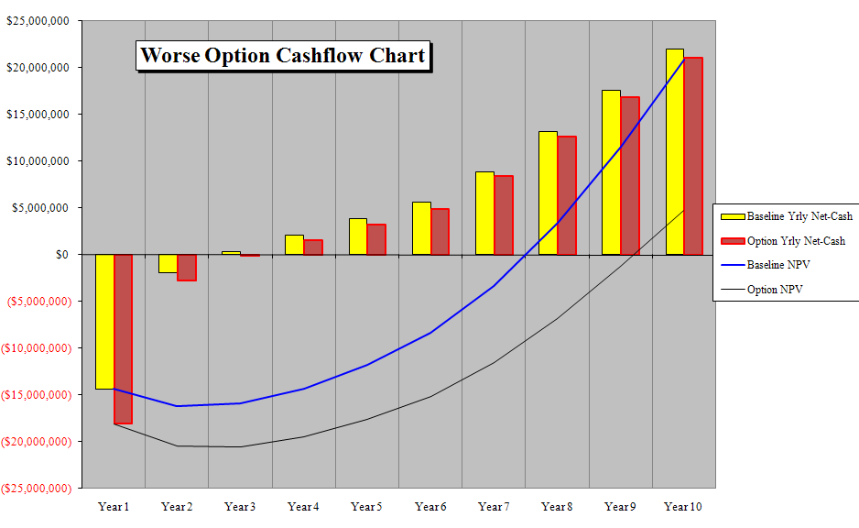

# Appendix E: Expert COSYSMO Calculator

Top of Form



|  |  |  |  |
| --- | --- | --- | --- |
|  | Expert COSYSMO - Systems Engineering Cost Model Risk Advisor | |  | | --- | | Model(s) Monte Carlo Risk  Auto Calculate | |

|  |  |  |  |  |  |  |  |  |  |  |  |  |  |  |  |  |  |  |  |  |  |
| --- | --- | --- | --- | --- | --- | --- | --- | --- | --- | --- | --- | --- | --- | --- | --- | --- | --- | --- | --- | --- | --- |
| **System Size**   |  |  |  |  | | --- | --- | --- | --- | |  | Easy | Nominal | Difficult | | # of System Requirements |  |  |  | | # of System Interfaces |  |  |  | | # of Algorithms |  |  |  | | # of Operational Scenarios |  |  |  | |  |

**System Cost Drivers**

|  |  |  |  |  |  |  |  |  |  |  |  |  |  |  |  |  |  |  |  |  |  |  |  |  |  |  |  |  |  |  |  |  |  |  |
| --- | --- | --- | --- | --- | --- | --- | --- | --- | --- | --- | --- | --- | --- | --- | --- | --- | --- | --- | --- | --- | --- | --- | --- | --- | --- | --- | --- | --- | --- | --- | --- | --- | --- | --- |
| |  |  | | --- | --- | | Requirements Understanding |  | | Architecture Understanding |  | | Level of Service Requirements |  | | Migration Complexity |  | | Technology Risk |  | | |  |  | | --- | --- | | Documentation |  | | # and Diversity of Installations/Platforms |  | | # of Recursive Levels in the Design |  | | Stakeholder Team Cohesion |  | | Personnel/Team Capability |  | | |  |  | | --- | --- | | Personnel Experience/Continuity |  | |  |  | |  |  | | Process Capability |  | | Multisite Coordination |  | | Tool Support |  | |

**System Labor Rates**  
Cost per Person-Month (Dollars)



**Results**

Bottom of Form

|  |  |  |  |  |  |  |  |  |  |  |  |  |  |  |  |  |  |  |  |  |  |  |  |  |  |  |  |  |  |  |  |  |  |  |  |  |  |  |  |  |  |  |  |  |  |  |  |  |  |  |  |  |  |  |  |  |  |  |  |  |  |  |  |  |  |  |  |  |  |  |  |  |  |  |  |  |  |  |  |  |  |  |  |  |  |  |  |  |  |  |  |  |
| --- | --- | --- | --- | --- | --- | --- | --- | --- | --- | --- | --- | --- | --- | --- | --- | --- | --- | --- | --- | --- | --- | --- | --- | --- | --- | --- | --- | --- | --- | --- | --- | --- | --- | --- | --- | --- | --- | --- | --- | --- | --- | --- | --- | --- | --- | --- | --- | --- | --- | --- | --- | --- | --- | --- | --- | --- | --- | --- | --- | --- | --- | --- | --- | --- | --- | --- | --- | --- | --- | --- | --- | --- | --- | --- | --- | --- | --- | --- | --- | --- | --- | --- | --- | --- | --- | --- | --- | --- | --- | --- | --- | --- |
| **Systems Engineering**  Effort = 553 Person-months Schedule = 12 Months Cost = $12615986   |  |  | | --- | --- | | **Effort Distribution (Person-Months)** | **Risk Summary** |  |  |  |  |  |  |  |  |  |  |  |  |  |  |  |  |  |  |  |  |  |  |  |  |  |  |  |  |  |  |  |  |  |  |  |  |  |  |  |  |  |  |  |  |  |  |  |  |  |  |  |  | | --- | --- | --- | --- | --- | --- | --- | --- | --- | --- | --- | --- | --- | --- | --- | --- | --- | --- | --- | --- | --- | --- | --- | --- | --- | --- | --- | --- | --- | --- | --- | --- | --- | --- | --- | --- | --- | --- | --- | --- | --- | --- | --- | --- | --- | --- | --- | --- | --- | --- | --- | | |  |  |  |  |  | | --- | --- | --- | --- | --- | | Phase / Activity | Conceptualize | Develop | Operational Test and Evaluation | Transition to Operation | | Acquisition and Supply | 10.8 | 19.8 | 5.0 | 3.1 | | Technical Management | 20.7 | 35.7 | 23.5 | 14.1 | | System Design | 56.4 | 66.4 | 28.2 | 14.9 | | Product Realization | 10.8 | 24.9 | 26.6 | 20.7 | | Product Evaluation | 30.9 | 46.3 | 68.6 | 25.7 | | |  |  |  |  |  |  |  |  |  |  |  |  |  |  |  |  |  |  | | --- | --- | --- | --- | --- | --- | --- | --- | --- | --- | --- | --- | --- | --- | --- | --- | --- | --- | | |  |  |  |  |  |  |  | | --- | --- | --- | --- | --- | --- | --- | | Product | 5 | |  |  |  |  | | --- | --- | --- | --- | | |  |  | | --- | --- | | |  | | --- | |  | | |  | | | Process | 0 | |  |  | | --- | --- | |  |  | | | People | 0 | |  |  | | --- | --- | |  |  | | | |  |   **Risk Mitigation Guidance**   The risk mitigation guidance below shows alternatives for consideration in specific project  environments.   |  |  |  | | --- | --- | --- | | Risk Exposure Points | Description | Alternatives | | 1.3 | Architecture Understanding = Nominal *and* Documentation = Very High | Do more documentation | | 2.0 | Migration Complexity = Very High *and* Technology Risk = High | Acquire better technology to interface to legacy  system(s) or negotiate minimal interfacing | | 1.3 | Documentation = Very High *and* Process Capability = Nominal | Subcontract, hire or partner with high process  domain expertise | | 1.3 | Level of Service Requirements = Nominal *and* Documentation = Very High | Extensive documentation to support  traceability for high interoperability | | 3.9 | Migration Complexity = Very High *and* Documentation = Very High | Find old documents and people to translate them,  seek analogous documentation and learn from it,  reverse-engineer old system | | 3.4 | Technology Risk = High *and* Documentation = Very High | Prototype, modeling and simulation, trade  studies | | 1.3 | Documentation = Very High *and* # of Recursive Levels in the Design = Nominal | TBS | | 1.3 | Documentation = Very High *and* Stakeholder Team Cohesion = Nominal | TBS | | 1.3 | Documentation = Very High *and* Personnel/Team Capability = Nominal | TBS | | 1.3 | Documentation = Very High *and* Personnel Experience/Continuity = Nominal | TBS | | 1.3 | Documentation = Very High *and* Multisite Coordination = Nominal | TBS | | 1.3 | Documentation = Very High *and* Tool Support = Nominal | TBS |   Total Risk Exposure Points = 20.9  Your output file is  <http://csse.usc.edu/tools/data/COSYSMO_November_3_2009_17_56_10_75431.txt>   Created by Ray Madachy at the Naval Postgraduate School. For more information contact him  at rjmadach@nps.edu |

1. http://www.airforce-magazine.com/MagazineArchive/Pages/2008/October%202008/1008aircraft.aspx
2. http://www.navytimes.com/news/2009/10/navy_leanmanning_101909w/
3. <http://www.cotsjournalonline.com/articles/view/100867>